**Face Recognition Based Attendance System**

**Problem Statement**

Attendance is an important part of daily classroom evaluation. At the beginning and ending of class, it is usually checked by the teacher, but it may appear that a teacher may miss someone or some students answer multiple times. Face recognition-based attendance system is a problem of recognizing face for taking attendance by using face recognition technology based on high-definition monitor video and other information technology.

The concept of face recognition is to give a computer system the ability of finding and recognizing human faces fast and precisely in images or videos. Numerous algorithms and techniques have been developed for improving the performance of face recognition. Recently

Deep learning has been highly explored for computer vision applications. Human brain can automatically and instantly detect and recognize multiple faces. But when it comes to computer, it is very difficult to do all the challenging tasks on the level of human brain. The face recognition is an integral part of biometrics. In biometrics, basic traits of human are matched to the existing data. Facial features are extracted and implemented through algorithms, which are efficient and some modifications are done to improve the existing algorithm models. Computers that detect and recognize faces could be applied to a wide variety of practical applications including criminal identification, security systems, identity verification etc. The face recognition

system generally involves two stages:

* Face Detection – where the input image is searched to find any face, then image processing

cleans up the facial image for easier recognition.

* Face Recognition – where the detected and processed face is compared to the database of known faces to decide who that person is.

**Background**

Many works related to Radio Frequency Identification (RFID) based Attendance Systems exist in the literature. In RFID based system, students carry a RFID tag type ID card and they need to place that on the card reader to record their attendance. RS232 is used to connect the system to the computer and save the recorded attendance from the database. This system may give rise to the problem of fraudulent access. Unauthorized person may make use of authorized ID card and enter the organization. Fingerprint based Attendance Systemhas a portable fingerprint device which can be passed among the students to place their finger on the sensor during the lecture time without the instructor’s intervention. This system guarantees a fool-proof method for marking the attendance. The problem with this approach is that passing of the device during the lecture time may distract the attention of the students.

Face detection is a basic technology of human-computer interaction. It can get information from the faces in pictures or video. Face recognition technology analyses the face image to extract the facial feature, and then identify specific target. The development of deep learning technology further improves the accuracy of face recognition. Deep Learning CNNs (Convolutional Neural

Networks) have made significant breakthrough in image classification. The deep learning model DeepID developed by the Computer Vision Research Group, have achieved a recognition rate of 99.15% on LFW database, which is higher than that of human eye with 97.52%

**Methodology**

The attendance system based on face detection algorithm and face recognition algorithm includes following modules

(1) Record a video to ensure that every student is appeared in the video.

(2) Separate a frame per minute for class attendance.

(3) Apply deep learning algorithm CNN for face detection module. Detect all students’ faces and

output coordinates.

(4) Apply deep learning face recognition algorithm for face recognition.

(5) Automatic attendance analysis module. The seats of students are fixed so do not contrast their faces’ coordinate and determine the identity of each student to achieve automatic attendance.

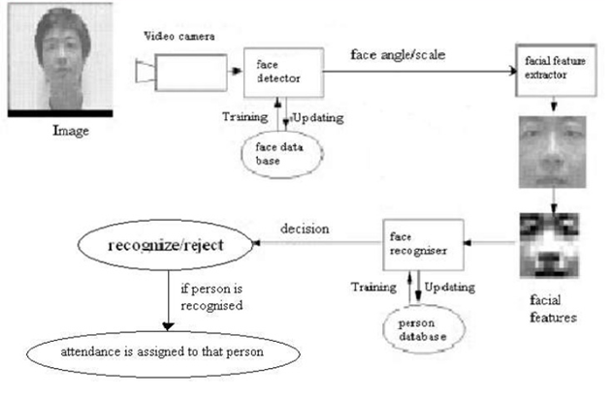

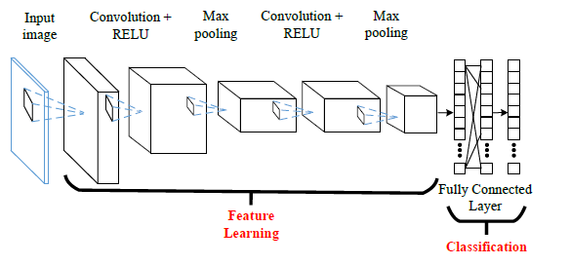

“A New Method for Face Recognition Using Convolutional Neural Network”, Patrik KAMENCAY, Miroslav BENCO, Tomas MIZDOS, Roman RADIL.

**Experimental Design**

***Dataset***

The ORL Database of Faces, contains ten different images of each of 40 distinct subjects (400 different images).

***Evaluation Measures***

Measures such as accuracy and Mean Average Precision (MAP) will be computed for the face recognition. Following are the three ways that can be used to estimate the performance of face recognition based attendance system based on deep learning models in Python using the Keras library:

* Use Automatic Verification Datasets.
* Use Manual Verification Datasets.
* Use Manual k-Fold Cross Validation.

***Software and Hardware Requirements***

Python based Computer Vision and Deep Learning libraries will be exploited for the development and experimentation of the project. Tools such as Anaconda Python, and libraries such as OpenCV, Tensorflow, and Keras will be utilized for this process. Training will be conducted on NVIDIA GPUs for training the end-to-end version of CNN based object detection model.

**References**

[1] R. Girshick, “Fast R-CNN,” in IEEE International Conference on Computer Vision (ICCV), 2015

[2] Yang B, Yan J, Lei Z, et al. Convolutional Channel Features for Pedestrian, Face and Edge Detection [J].

Computer Science, 2015:82-90.

[3] Michał Dolecki, Paweł Karczmarek, Adam Kiersztyn, Witold Pedrycz, "Face recognition by humans performed on basis of linguistic descriptors and neural networks", Neural Networks (IJCNN) 2016 International Joint Conference on, pp. 5135-5140, 2016, ISSN 2161-4407.

[4] A. Krizhevsky, I. Sutskever, and G. E. Hinton, “Imagenet classification with deep convolutional neural networks,” in Advances in Neural Information Processing Systems 25: 26th Annual Conference on Neural Information Processing Systems 2012. Proceedings of a meeting held on December 3-6, 2012, (Lake Tahoe, Nevada, United States), pp. 1106–1114, 2012.

[5] Soniya, Paul S, Singh L. A review on advances in deep learning[C]// IEEE Workshop on Computational Intelligence: Theories, Applications and Future Directions. IEEE, 2015:1-6.

[6] Shuo Yang; Ping Luo; Chen Change Loy; Xiaoou Tang,”WIDER FACE:A Face Detection Benchmark,” 2016 IEEE Conference on Computer Vision and Pattern Recognition (CVPR) Year: 2016 Pages: 5525 - 5533, DOI: 10.1109/CVPR.2016.596

[7] Xiaofei He; Shuicheng Yan; Yuxiao Hu; Niyogi, P.; Hong-Jiang Zhang, IEEE Transactions on Pattern Analysis and Machine Intelligence, pp. 328 340, 2005.

[8] M. Turk and A. Pentland, Eigenfaces for recognition, Journal of Cognitive Neuroscience, 3(1), pp. 7186, 1991.

[9] H. Lu, K. N. Plataniotis, and A. N. Venetsanopoulos, Mpca: Multilinear principal component analysis of tensor objects, IEEE Trans. on Neural Networks, 19(1):1839,2008.

[12] Ming Du, Aswin C. Sankaranarayanan, and Rama Chellappa , Robust Face Recognition from Multi-View Videos , IEEE TRANSACTIONS ON IMAGE PROCESSING,VOL. 23, NO. 3, MARCH 2014.